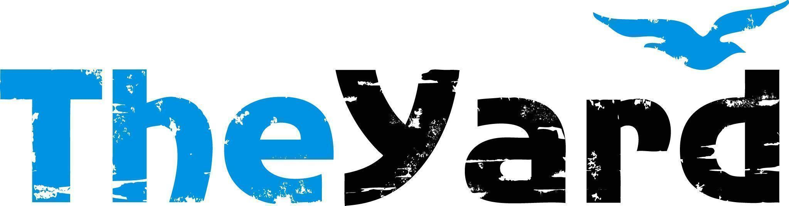
Post Office Box 405, Chilmark, MA 02535-0405
508.645.9662 I info@dancetheyard.org I dancetheyard.org
A contemporary artist residency, dance and performance center,
for Martha’s Vineyard and beyond

CONTACT:
Leslie Trotter, Marketing Manager: leslietrotter@dancetheyard.org

FOR IMMEDIATE LISTING and RELEASE
July 5, 2023

Music From The Sole
In Residence July 12-17, 2023
Performance July 15, 2023 at 7pm | Martha’s Vineyard Performing Arts Center

[July 5, 2023] — (Chilmark, Massachusetts) Music From The Sole is a tap dance and live music company that celebrates tap's Afro-diasporic roots, particularly its connections to Afro-Brazilian dance and music, and its lineage to forms like house dance and passinho (Brazilian funk). Led by Brazilian dancer/ choreographer Leonardo Sandoval and by bassist/ composer Gregory Richardson, their work embraces tap’s unique nature as a blend of sound and movement, incorporating wide-ranging influences like samba, passinho, Afro-Cuban, jazz, and house.

Tap, percussive dance, samba, house, and live music come together in I Didn’t Come to Stay. In the work, Sandoval and Richardson lead eight dancers and a five-piece band in a performance that explores tap’s lineage and connections to other Afro-Diasporic forms. Together the pair embrace shared roots across the diaspora and reflect on racial and cultural identity, while also celebrating the joy, strength, depth, and virtuosity of Black dance and music.

As part of its mission to bring tap, America's original vernacular dance, to new audiences, the company appears as both a dance company and percussive-led band at dance and music venues, including The Yard and recently at Harlem Stage, Lincoln Center, Jacob’s Pillow, Caramoor Jazz Festival, Bryant Park, and the Guggenheim.

Details:
Performance Date: July 15th at 7pm
Location: The Martha’s Vineyard Performing Arts Center, 100 Edgartown Road, MA

Tickets:
Adult: $33
Senior/Military: $28
Youth/Student: $13
Purchase: I Didn't Come To Stay

Community Activities:
Visit our website’s calendar for a comprehensive view of our summer programming.

Upcoming Shows:
Rainbow Serpent Collective: The Rainbow Serpent is a multidisciplinary collective based in Pittsburgh that advances Black LGBTQ culture through an exploration of emerging technologies, advanced healing protocols, African cosmologies, and multimedia art. They create and sponsor work in many media, including live performance, public installation, literature, photography, film, animation, painting, and sculpture.
Performance July 29th at 7pm, Patricia Nanon Theater at The Yard
For more information & tickets: Rainbow Serpent Collective

About The Yard
The Yard is a creation and performance platform for artists from around the globe, and we offer exhilarating, wide-ranging, and educational arts experiences through performances, residencies, and community activities. We present performances by international, national, and local artists; provide paid residencies for artists; offer inter-generational engagement programs and classes for our island community; and bring dance and creativity-centered education programs into schools. Our community programs run year-round and can be found on The Yard’s campus and in partner locations across the island of Martha’s Vineyard. Please visit www.dancetheyard.org for more information.

The Yard Access program is designed to make The Yard programs accessible to a wider portion of our community. Find more information here.
- - - -

This program is supported by the following generous sponsors:
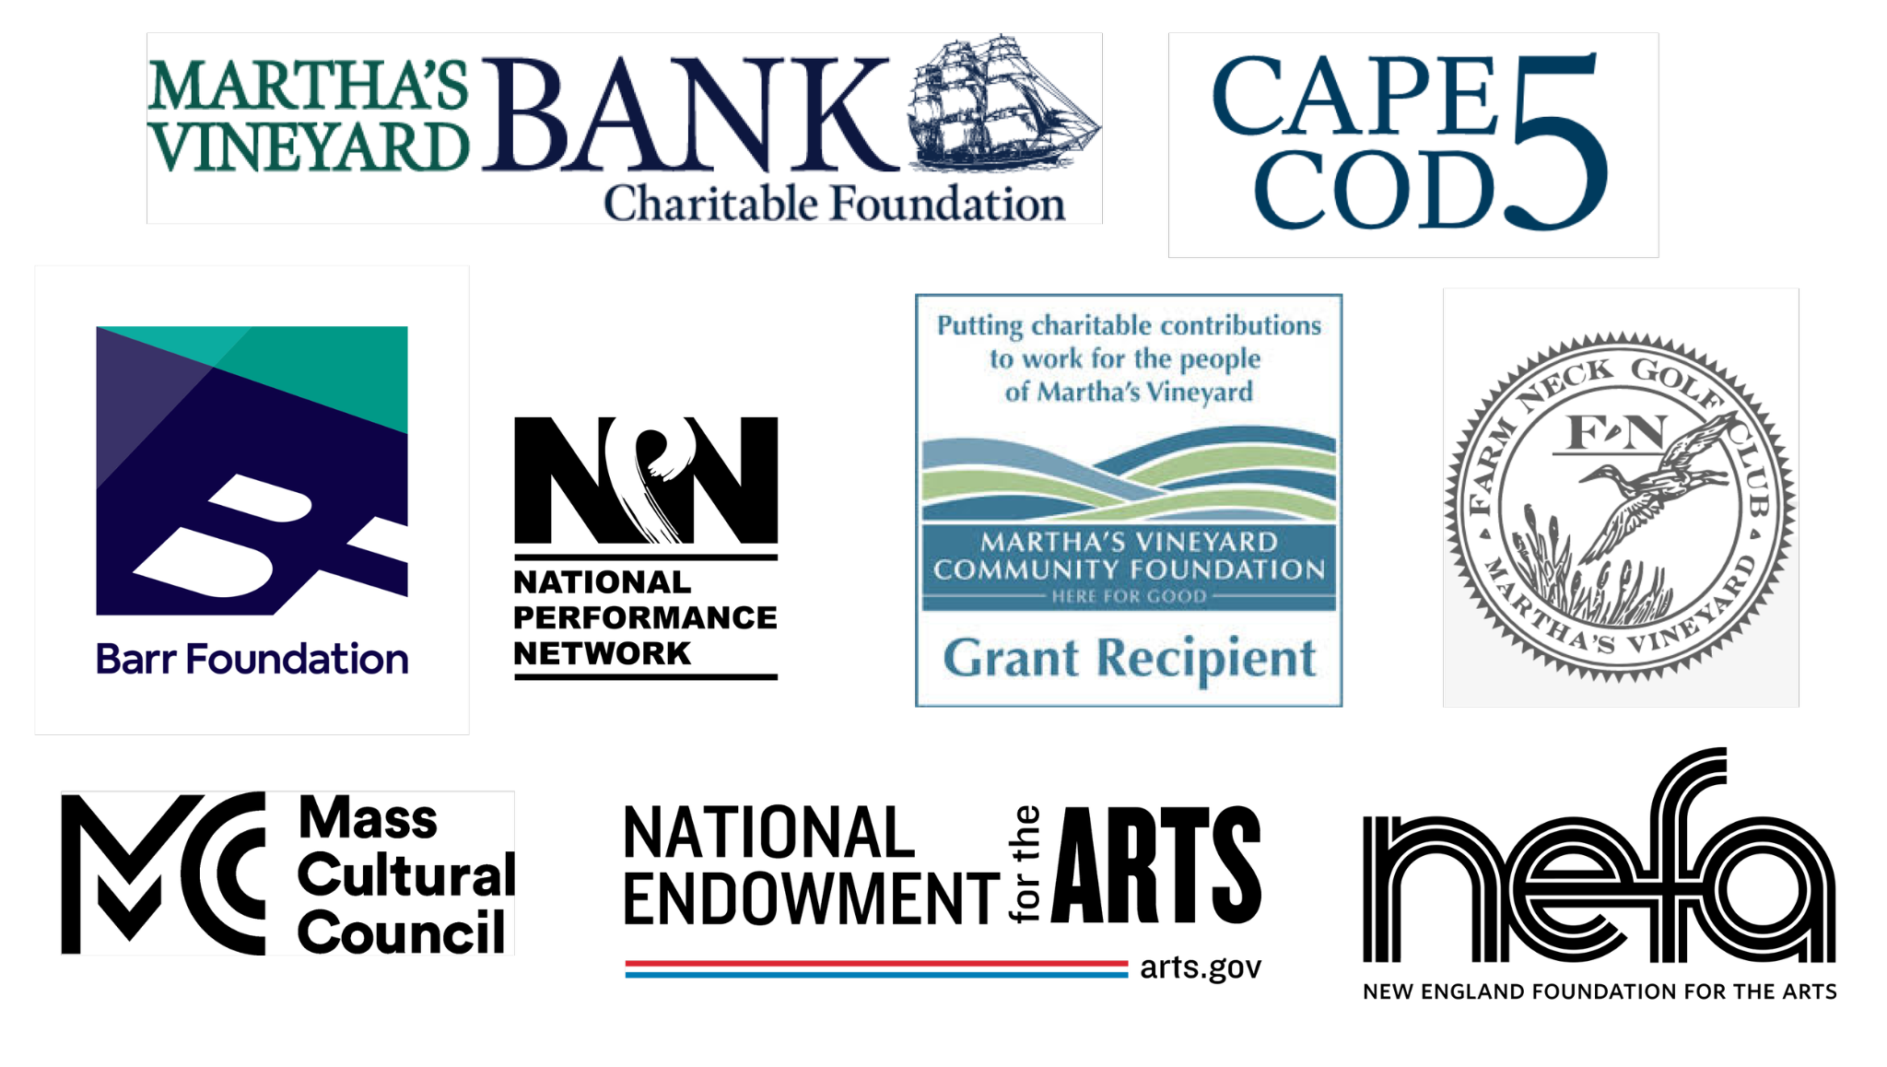
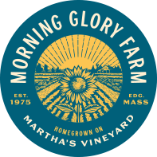
THE LOST ART OF DREAMING has been commissioned by American Dance Festival, Dance Place (Washington DC), 7 Stages (Atlanta GA), Velocity Dance Center (Seattle WA), Queer Cultural Center (San Francisco CA), and Yerba Buena Gardens Festival; and developed through residencies with the National Choreography Center in Akron (Akron OH) and Z Space (San Francisco CA).
THE LOST ART OF DREAMING has been awarded support from the commissioners above, and from the California Arts Council, Kenneth Rainin Foundation, New England Foundation for the Arts’ National Dance Project – with lead funding from the Doris Duke Charitable Foundation and The Andrew W. Mellon Foundation, National Endowment for the Arts, National Performance Network and San Francisco Arts Commission.
.

SEED. GROW. REAP. REPEAT: THE NATURE OF THE YARD.

