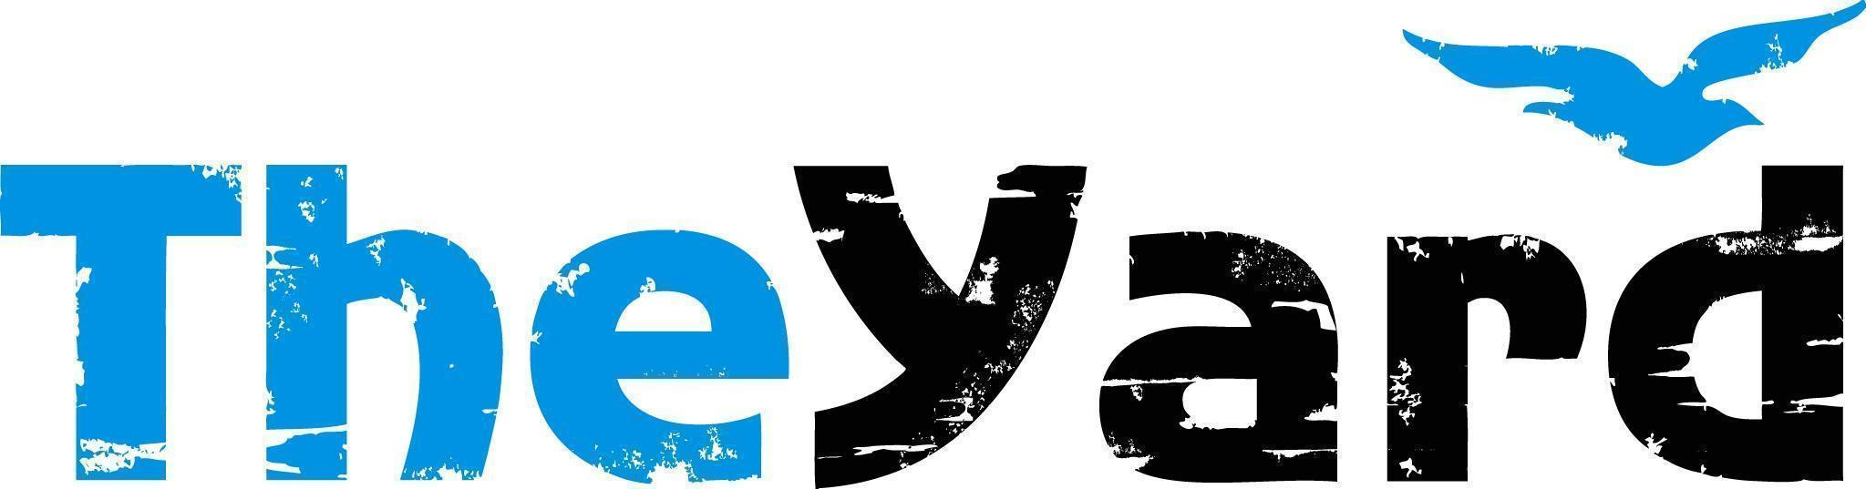
Post Office Box 405, Chilmark, MA 02535-0405
508.645.9662 I info@dancetheyard.org I dancetheyard.org
A contemporary artist residency, dance and performance center,
for Martha’s Vineyard and beyond

CONTACT:
Stephanie Pacheco, Executive Director: stephaniepacheco@dancetheyard.org
Leslie Trotter, Marketing Manager: leslietrotter@dancetheyard.org

FOR IMMEDIATE LISTING and RELEASE
June 19. 2023

Sandglass Theater
In Residency June 14 - 26
Performance Jun 24, 2023
Recommended for ages 14+

[June 19, 2023] — (Chilmark, Massachusetts) Since 1982, Sandglass Theater has designed puppets and productions touring internationally across nearly 30 countries, performing in theaters, festivals and cultural institutions, while winning numerous international prizes. Creative Director, Shoshana Bass carries forward her legacy following in the footsteps of her parents, the original founders of Sandglass Theater in 1982.
The theater company’s newest work-in-progress piece, Feral, invites audiences on a woman’s journey as she experiences the tension between learned behaviors and intuitive knowledge. The piece uses visual imagery, puppetry, and music to investigate cultural gaslighting of original knowledge and to celebrate the transformational process that can lead to individual and cultural repair.

“Theater and dance go together, but the addition of puppets into that mix, and the choreography is especially exciting," says Program Director Yvonne Mendez. “We’re thrilled to see the integration of life-size puppets and dance on stage!” Artistic Director and Project Creator Shoshana Bass is also delighted about developing this work. “The ability to play with the movement aspect is what makes the collaboration with the Yard really exciting, because there is so much dance imbued in that space; we’re excited to feed off of that magic.”

Details:
Performance Date: June 24, 2023 at 7pm
Location: The Yard, Patricia Nanon Theater
Recommended for ages 14+

Upcoming Shows:
Sean Dorsey Dance: Emmy award winner Sean Dorsey invites audiences to connect with joy and pleasure in “The Lost Art of Dreaming” performing July 7th and 8th.
Music From The Sole: A company that celebrates tap's Afro-diasporic roots performing "I Didn’t Come to Stay” July 15th at the Martha’s Vineyard Performing Arts Center.

- - - -

This program is supported by the following generous sponsors:

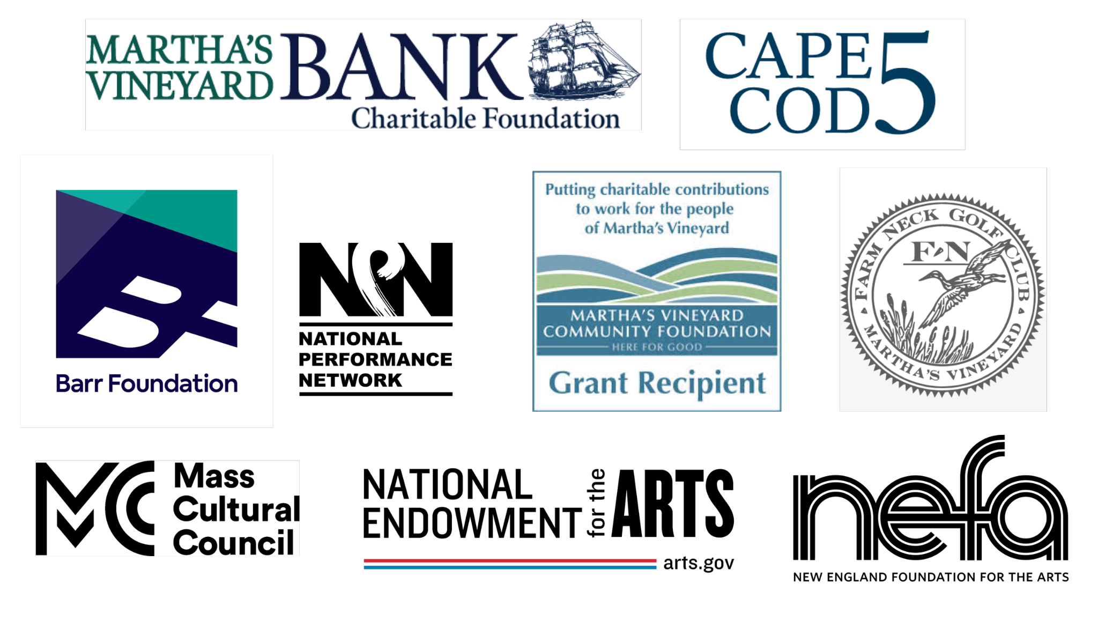

Also by grants from the Jim Henson Foundation, the Network of Ensemble Theaters NET/TEN Virtual Exploration grant and by the National Endowment for the Arts. To find out more about how National Endowment for the Arts grants impact individuals and communities, visit www.arts.gov. Feral is a National Performance Network (NPN) Creation & Development Fund Project grant with co-commissioners The Yard (MA), Next Stage Arts Project (VT), Bunnell Street Arts Center (AK), Dancers Workshop (Wyoming) and NPN. More information: www.npnweb.org.

####
The Yard is a creation and performance platform for artists from around the globe, and we offer exhilarating, wide-ranging, and educational arts experiences through performances, residencies, and community activities. We present performances by international, national, and local artists; provide paid residencies for artists; offer inter-generational engagement programs and classes for our island community; and bring dance and creativity-centered education programs into schools. Our community programs run year-round and can be found on The Yard’s campus and in partner locations across the island of Martha’s Vineyard. Please visit www.dancetheyard.org for more information.

SEED. GROW. REAP. REPEAT: THE NATURE OF THE YARD.

