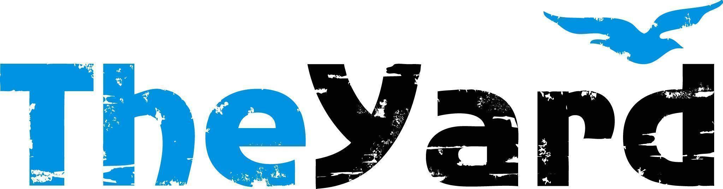
Post Office Box 405, Chilmark, MA 02535-0405
508.645.9662 I info@dancetheyard.org I dancetheyard.org
A contemporary artist residency, dance and performance center,
for Martha’s Vineyard and beyond

CONTACT:
Leslie Trotter, Marketing Manager: leslietrotter@dancetheyard.org

FOR IMMEDIATE LISTING and RELEASE
July 13, 2023

Rainbow Serpent Collective
In Residency July 19-30, 2023
Performance July 29, 2023 at 7pm | Patricia Nanon Theater

[July 13, 2023] — (Chilmark, Massachusetts) The Rainbow Serpent is a multidisciplinary collective based in Pittsburgh that advances Black LGBTQ culture through an exploration of emerging technologies, advanced healing protocols, African cosmologies, and multimedia art. They create and sponsor work in many media, including live performance, public installation, literature, photography, film, animation, painting, and sculpture.

While at The Yard they will present an in-progress showing of their new piece — The Four World Ages. This production depicts the four eras of human history from the perspective of Nigerian-Igbo tradition — the Age of Universal Oneness, the Age of Self-Awareness, the Age of Light, and our current Age of Suffering. The piece will feature four dancers who will be adorned with body paint as they enact this sweeping saga, and the performance will employ dynamic projections, innovative light design, and spatial augmented reality components.

Details:
Performance Date: July 29th at 7pm
Location: The Patricia Nanon Theater

Tickets:
Adult: $33
Senior/Military: $28
Youth/Student: $13
Purchase: The Four World Stages

Community Activities:
Miracles in Motion: A Dance Healing Workshop
Wednesday, July 26th at 10:30am
This one-hour workshop with Rainbow Serpent Collective is open to people of ALL LEVELS. Miracles in Motion is a dance modality that promotes healing on physical, spiritual, mental, and energetic levels. Through guided meditation, choreography, and improvisation, this workshop introduces participants to dance rituals, dance energy healing, quantum jumping, and somatic psychotherapy techniques. Come to find freedom, joy, and healing in the movement of dance!
Buy tickets: Classes and Workshops — The Yard
Visit our website’s calendar for a comprehensive view of our summer programming.

Upcoming Shows:
Urban Bush Women: Performances August 9-12 at 7pm, Private Pop Up in Oak Bluffs and Public Pop Up at Orange Peel Bakery in Aquinnah.
For more information & tickets: Urban Bush Women (2023) — The Yard

About The Yard
The Yard is a creation and performance platform for artists from around the globe, and we offer exhilarating, wide-ranging, and educational arts experiences through performances, residencies, and community activities. We present performances by international, national, and local artists; provide paid residencies for artists; offer inter-generational engagement programs and classes for our island community; and bring dance and creativity-centered education programs into schools. Our community programs run year-round and can be found on The Yard’s campus and in partner locations across the island of Martha’s Vineyard. Please visit www.dancetheyard.org for more information.

The Yard Access program is designed to make The Yard programs accessible to a wider portion of our community. Find more information here.
- - - -

This program is supported by the following generous sponsors:
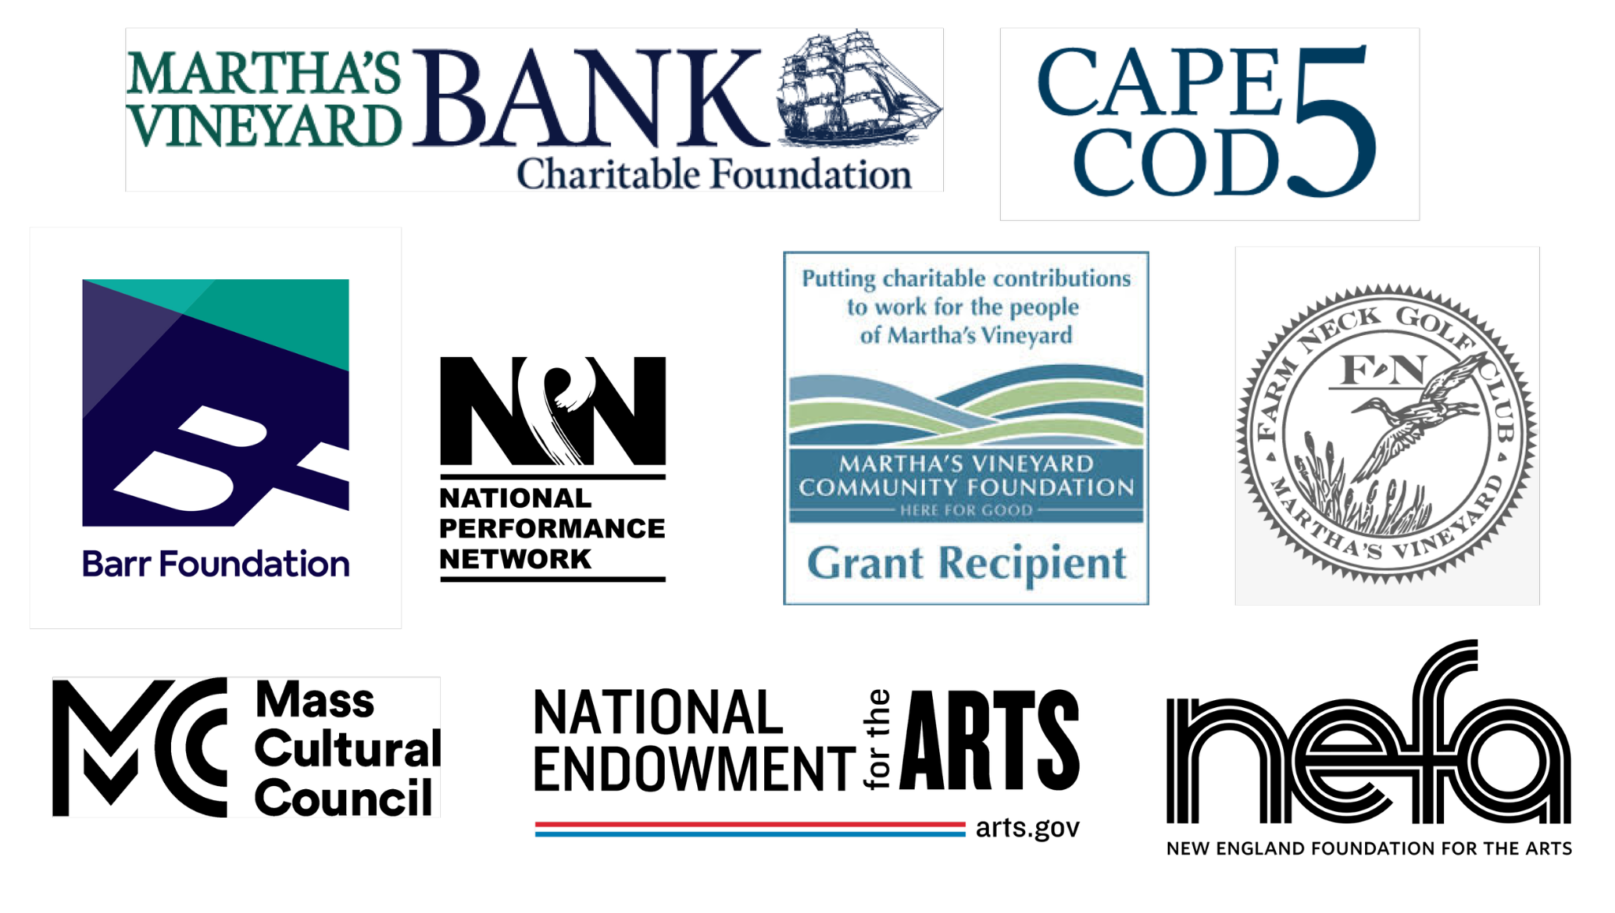
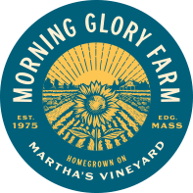
The creation of "The Four World Ages" was made possible with the support of the Advancing Black Arts in Pittsburgh Grants Program, The Frank-Ratchye STUDIO for Creative Inquiry at Carnegie Mellon University, the Carnegie Mellon University Entertainment Technology Center, and The Yard.
.

SEED. GROW. REAP. REPEAT: THE NATURE OF THE YARD.

